### App: D&D Character Tracker

*Usability Report*

Dipanwita Maulik

**I. PARTICIPANTS**

**Basic demographic information** (participant sample size: 5)

|  |  |  |  |
| --- | --- | --- | --- |
| **Name** | **Gender** | **Age** | **Occupation** |
| Samuel | Male | 21 | Undergraduate |
| Sara | Female | 23 | Undergraduate |
| Pat | Male | 22 | Undergraduate |
| Rachel | Female | 21 | Undergraduate |
| Evelyn | Female | 22 | Undergraduate |

**II. TASKS**

* Create a new character with all or some information filled in
* Create a new extra to add to the character’ sheets
* Edit created characters/extras and attempt to save

**III. OVERALL FINDINGS**

**General issues users encountered:**

The app is simple and easy to use and conveys exactly what it is intended for. The icons in the action bar were also obvious in what they did. However, the general issues encountered were in relation to the design. The users said it would be more convenient if the app had better feedback in case the users made a mistake while filling in the forms. Additionally, when adding a lot of items to one of the lists in the character sheet, no scroll bar appeared which made it hard for the user to tell if there were additional items in the list. Adding a scroll bar to the side would make this much more obvious. A third minor concern was that some of the wording was wording on a few screens were confusing. The final concern was that the app was rather boring looking, and it was suggested that it would look better with more color and some sort of design theme.

**IV. SPECIFIC FINDINGS**

**UI Feedback:**

No feedback for incorrect input; app will simply not do anything.

*Recommendation:*

*Add a toast when the user has incorrect input*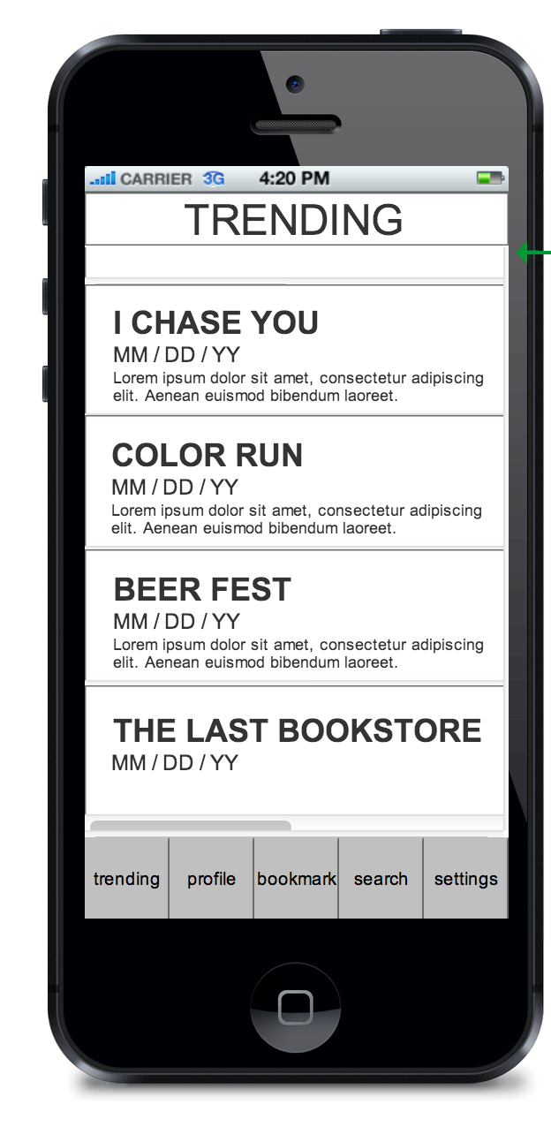

Edit Screen

*after*

Edit Screen

*before*

**Adding scrollbar:**

For long lists it wasn’t obvious that there were more items on the bottom, or even that you could continue to add items once you ran out of space. This was especially true for the smaller containers like feats, magic, armors, etc.

*Recommendation:*

*Make the scrollbar visible on touch so users know they can scroll down and that the number of items they can add isn’t necessarily limited.*



Character Editing

*before*

Character Editing

*after*

**Design scheme:**

While the app was easy to read and navigate it would look better with more colors and an overarching design.

*Recommendation:*

*One user suggested that having a fantasy-themed design scheme would help convey the fact that it was an app for D&D games. Other uses suggested using fancy fonts, though one cautioned that too much might take away the readability of the app. Another user also suggested making headings bold to differentiate them better.*

**Wording:**

The wording on some of the screens was confusing, particularly on differentiating between a description for an Extra and a value for it when adding an extra to a character.

*Recommendation:*

*Add the extra’s description below its name and change the title on the lower box to “value” instead.*



Start Screen

*before*

Start Screen

*after*